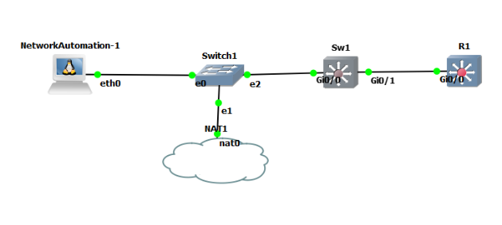

192.168.122.73

192.168.122.72